The Math Behind Neural Networks
Jack Paulson

1. Network Setup
This project shows how calculus and linear algebra are used to train a neural network to predict whether a semiconductor wafer is defective. I calculate a forward pass, use the chain rule to find every weight and bias gradient, and take one gradient descent step. The update moves the prediction toward the correct target and lowers the loss.

A 3-3-2-1 neural network
The network has three input features, three neurons in Hidden Layer 1, two neurons in Hidden Layer 2, and one output neuron. Every neuron in one layer connects to every neuron in the next layer. Each hidden and output neuron uses the sigmoid activation function.
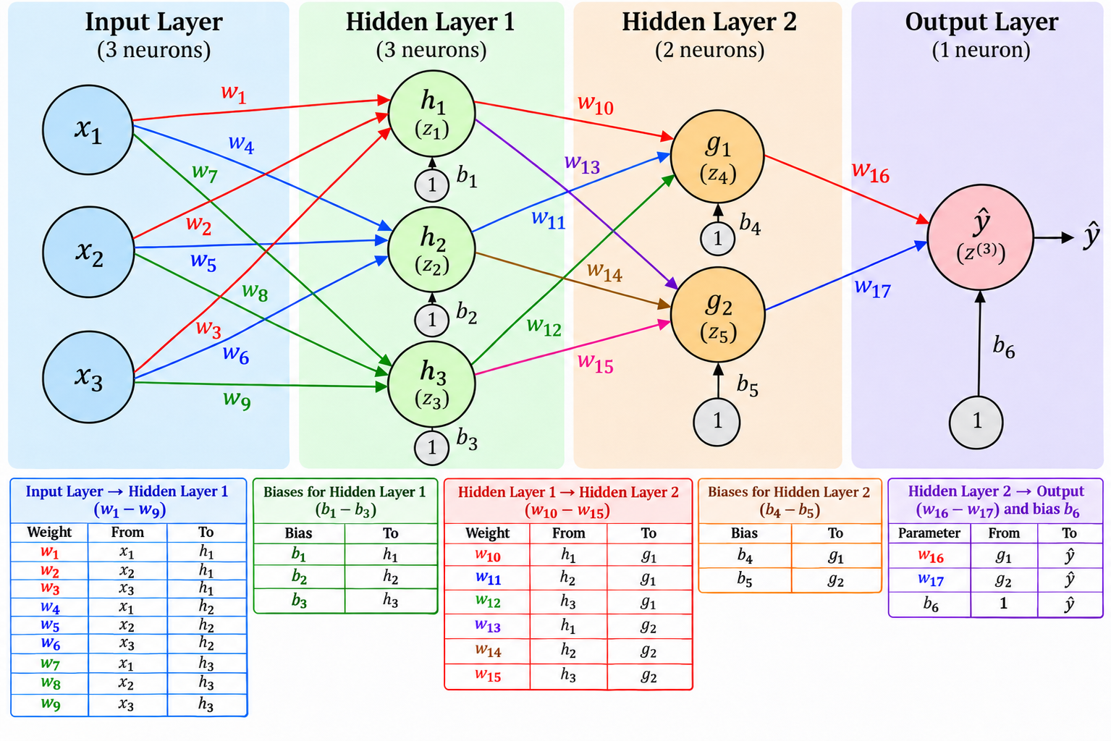

Training example and notation
The inputs represent arbitrary measurements for temperature, production speed, and contamination level.
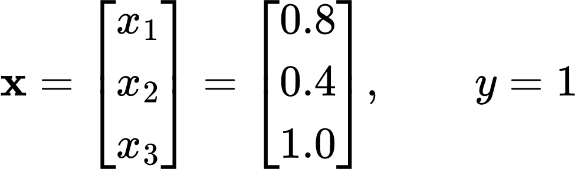
The target is y = 1 for a defective wafer and y = 0 for a good wafer. The output is the predicted probability that this wafer is defective.
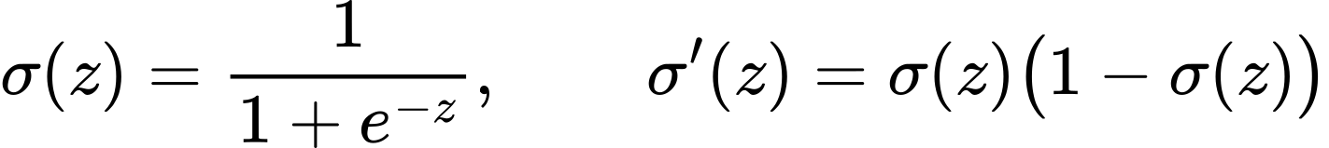
Each z is a weighted sum before activation. The h and g values are the hidden-layer outputs after activation. Biases b₁ through b₆ are scalars, and there is one for each non-input neuron.

2. Initial Weights and Biases

Input layer to Hidden Layer 1
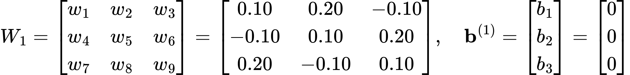
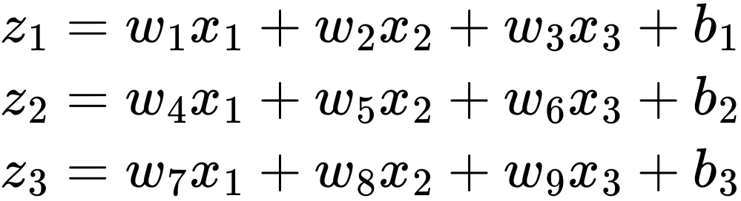

Hidden Layer 1 to Hidden Layer 2
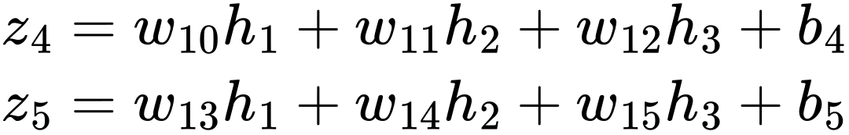

Hidden Layer 2 to the output

The whole network in matrix form
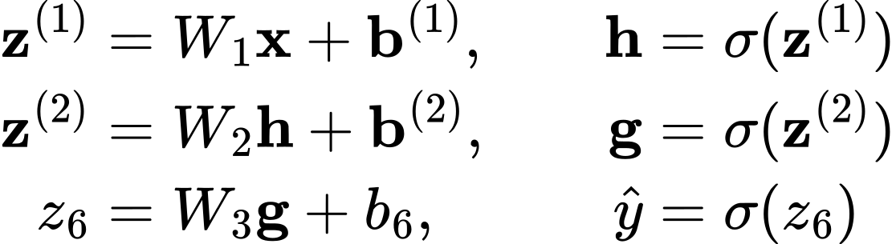
z⁽¹⁾ contains z₁, z₂, z₃, and z⁽²⁾ contains z₄, z₅. The sigmoid acts on each vector entry separately.

3. Forward Propagation and Loss

Calculate Hidden Layer 1
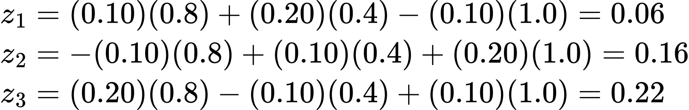
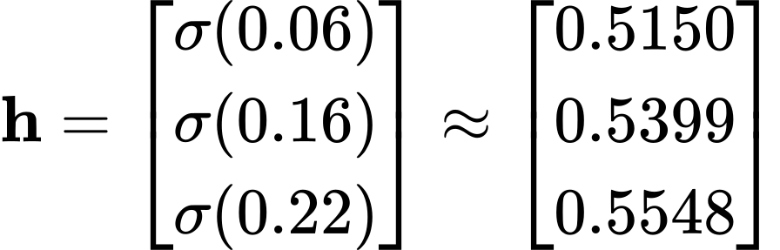

Calculate Hidden Layer 2
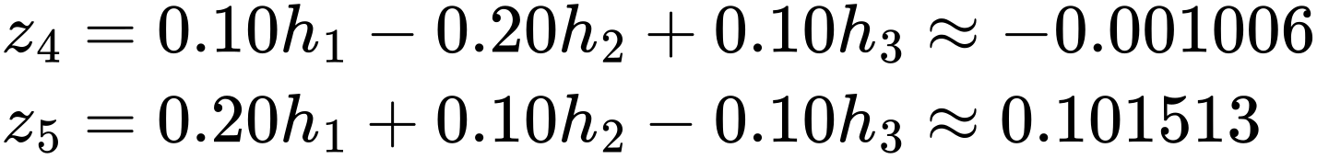
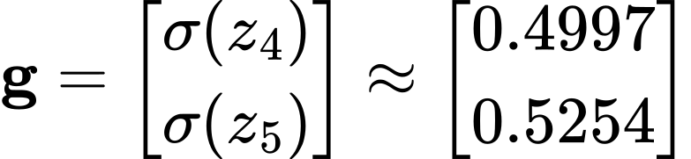

Calculate the output
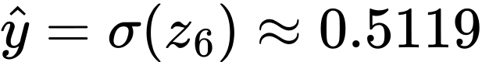
Before training, the network predicts a defective probability of about 51.2% for this wafer. The target is 1, so a higher prediction would be closer to the correct answer.

Calculate binary cross-entropy loss
The loss becomes smaller as the prediction moves toward 1.

4. Backpropagation at the Output
Backpropagation finds how each parameter affects the loss. You start at the output, where the loss is closest, and apply the chain rule backward through the network. The error signal for each neuron is δᵢ = ∂L/∂zᵢ.

How the prediction affects the loss
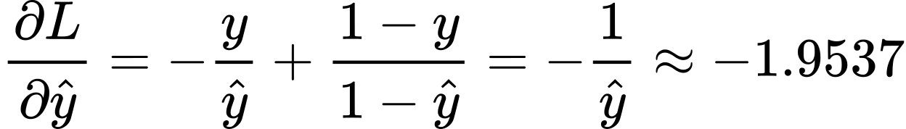
The derivative is negative, so increasing the prediction slightly would decrease the loss because the target is 1.

How the output weighted sum affects the prediction
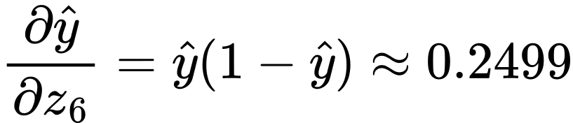
Increasing z₆ by 0.01 would increase the prediction by about 0.2499 × 0.01, or 0.0025, from 0.5119 to 0.5144.

Combine the derivatives with the chain rule
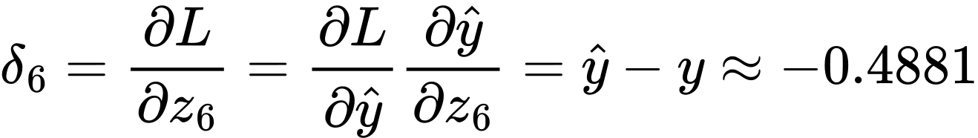
This is the output error signal. Its negative sign means a small increase in z₆ reduces the loss. For example, a change of 0.01 gives a loss change of about −0.004881.

Gradients for the output weights and bias
When differentiating with respect to one output weight, the other terms are constant. The derivative is the activation entering that weight. The bias is added directly, so its derivative is 1.
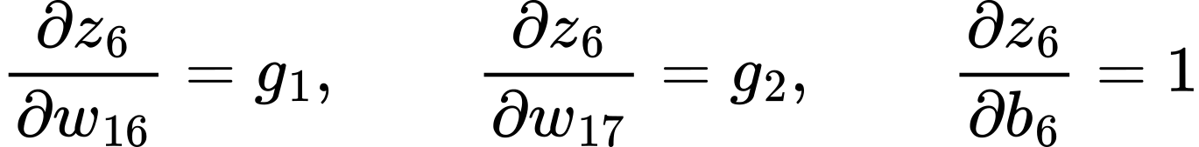
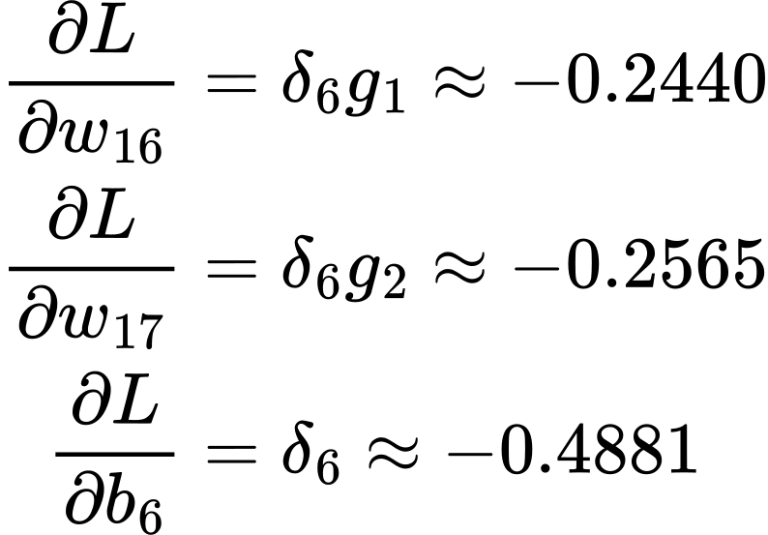
All three gradients are negative, so gradient descent will increase both output weights and the output bias.

5. Backpropagation Through Hidden Layer 2
Each neuron in Hidden Layer 2 affects the loss through the output neuron. You multiply the output error signal by the connecting weight and by the hidden neuron’s sigmoid derivative.

Error signal for the first neuron
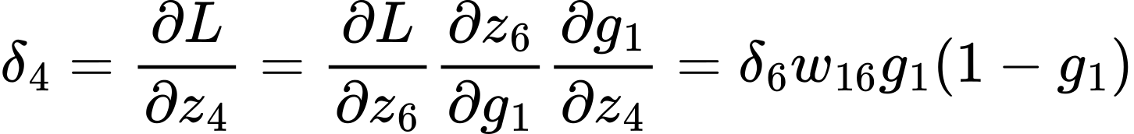

Error signal for the second neuron

Gradients for weights 10 through 15 and biases 4 and 5
For example, z₄ contains the term w₁₀h₁, so ∂z₄/∂w₁₀ = h₁. Applying the chain rule gives ∂L/∂w₁₀ = δ₄h₁. The other weights follow the same pattern.
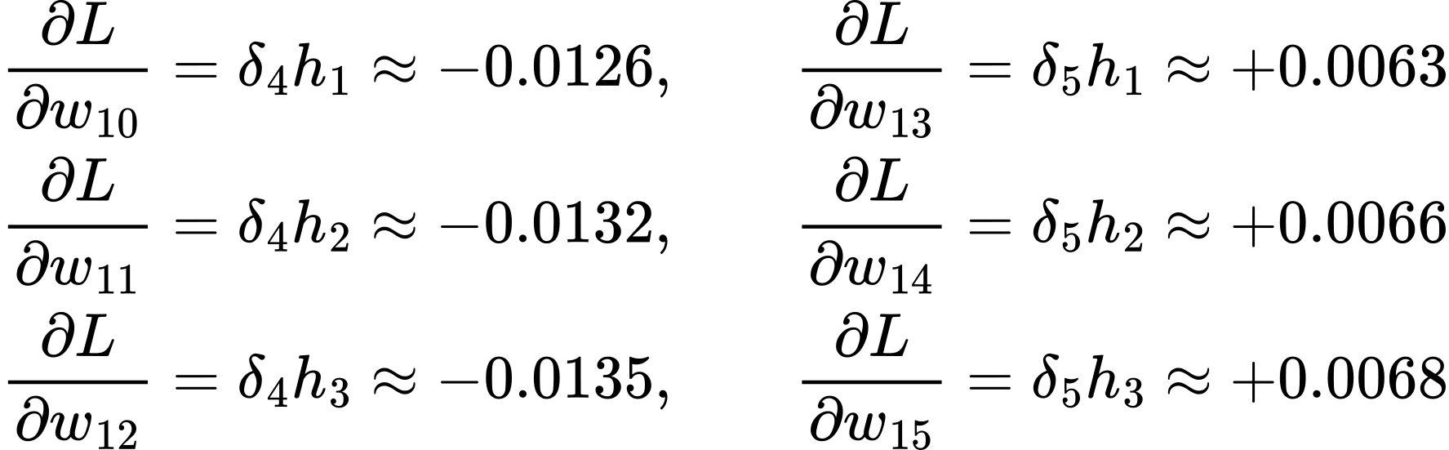
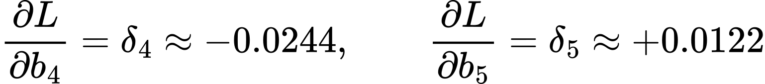
The rule is: weight gradient = neuron error signal × input entering that weight.
A bias gradient equals that neuron’s error signal.

6. Backpropagation Through Hidden Layer 1
Each neuron in Hidden Layer 1 feeds both neurons in Hidden Layer 2. You add the contributions from both paths before multiplying by the first-layer sigmoid derivative.

Error signal for the first neuron
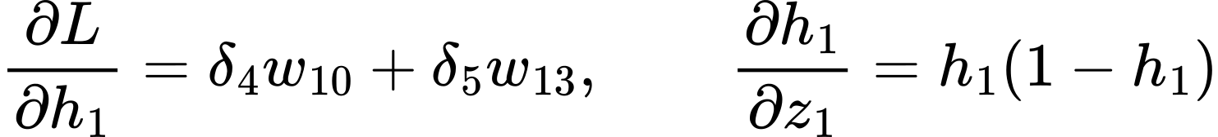
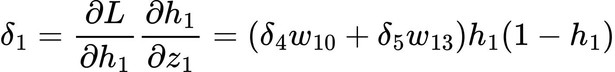

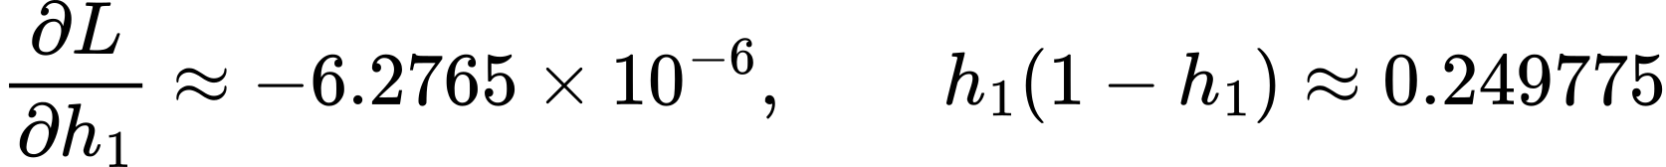

Error signal for the second neuron
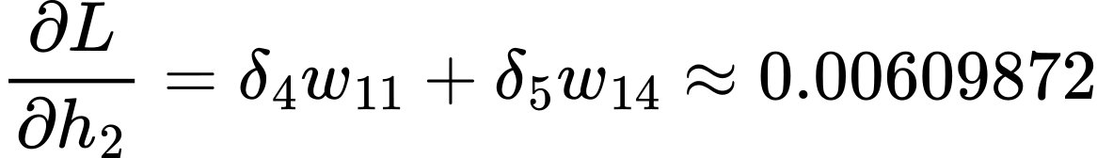

Error signal for the third neuron
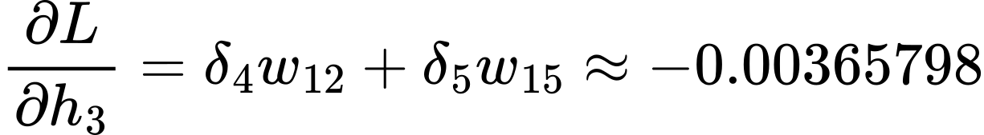
The addition in each expression factors in both paths to the loss. Multiplication by hᵢ(1 − hᵢ) then converts the derivative with respect to the activation into the derivative with respect to its weighted sum.

7. Gradients for Hidden Layer 1
The original inputs are x₁ = 0.8, x₂ = 0.4, and x₃ = 1.0.

Weights entering the first neuron
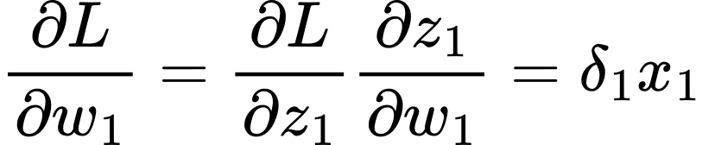
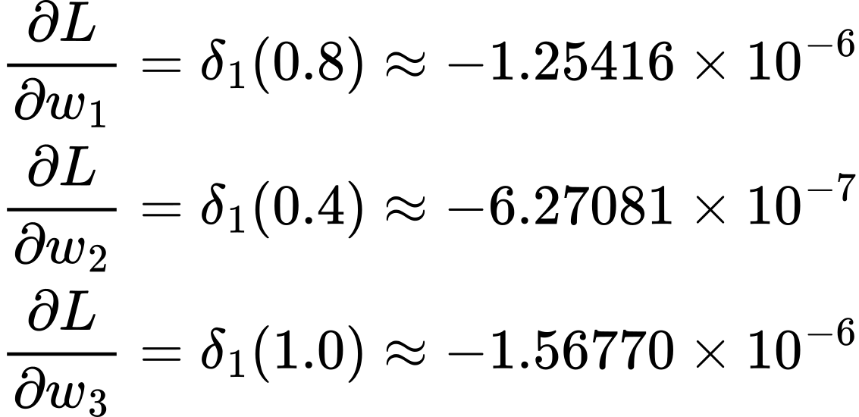

Weights entering the second neuron
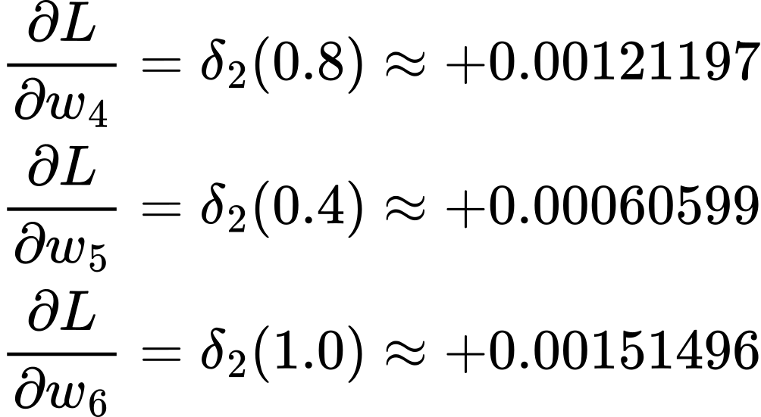

Weights entering the third neuron
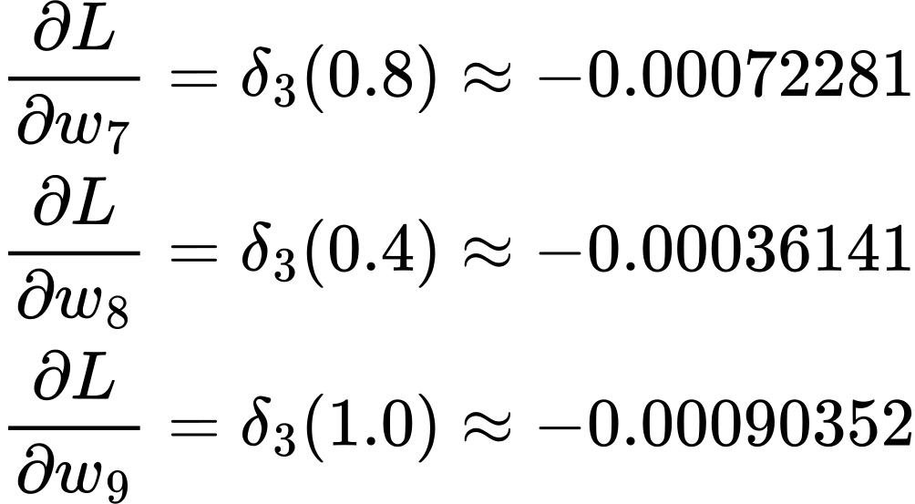

Bias gradients
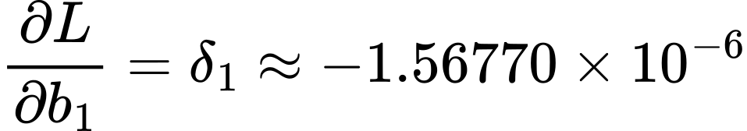
The gradient for every parameter has now been calculated. There are 17 weights and 6 biases.

8. Update the Parameters Using Gradient Descent
Backpropagation calculates the gradients. Gradient descent uses those gradients to update the parameters. The learning rate controls the size of the change. Here it is 0.1.
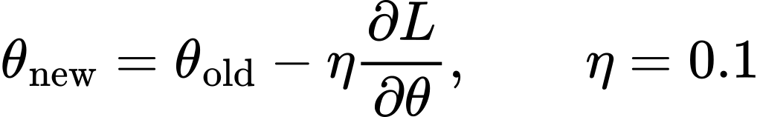

Worked updates for the output layer
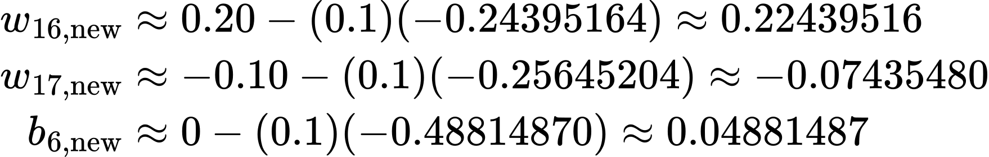

Updated Hidden Layer 2 parameters
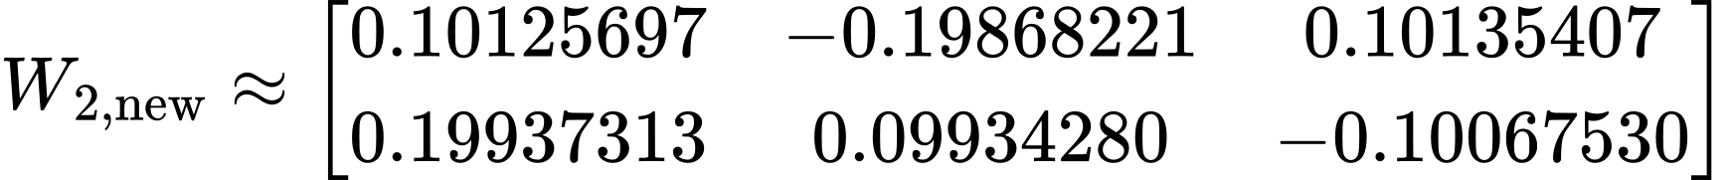
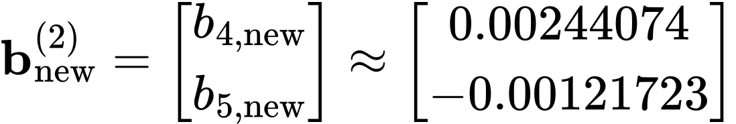

Updated Hidden Layer 1 parameters
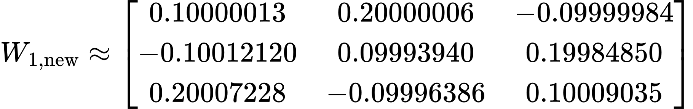
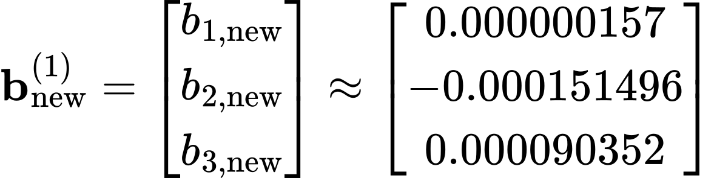
The order of weights within each matrix is the same as in the initial setup, so these matrices include all 17 updated weights.

9. Run Another Forward Pass and Compare
Then, I used the same input and target with the updated parameters to check whether one training step improved the prediction.

Recalculate Hidden Layer 1
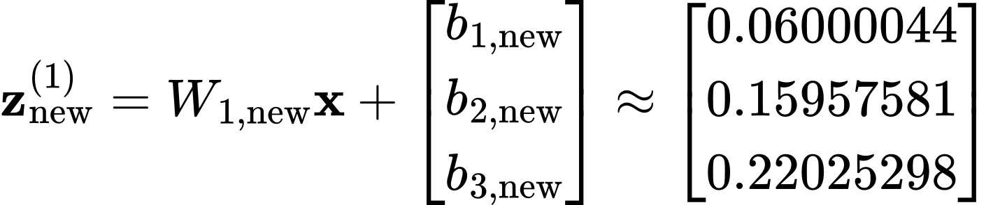
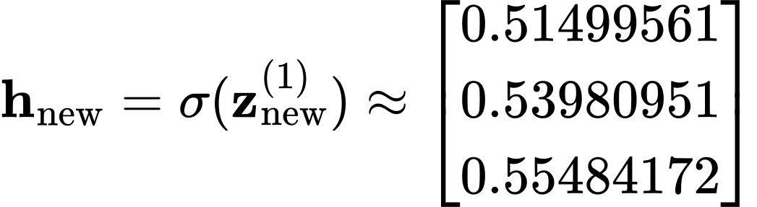

Recalculate Hidden Layer 2
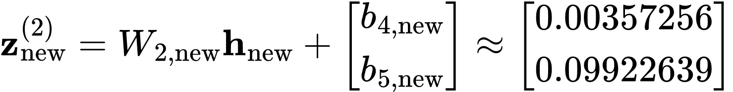
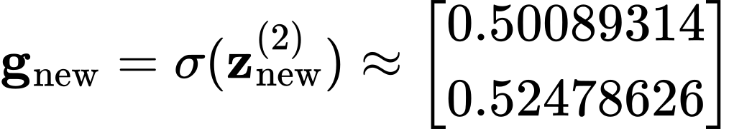

Recalculate the output and loss
Quantity | Before training | After one step
Predicted defective probability | 0.5119 | 0.5305
Binary cross entropy loss | 0.6697 | 0.6339

After one training step, the prediction increases from 0.5119 to 0.5305, and the loss decreases from 0.6697 to 0.6339. Because the true target is 1, the prediction moves in the correct direction.

